Early Faulty Battery Detection in Electric Vehicles Based on Self-Discharge Rate Analysis

Shubo Ted Yulin Jonathan Steven

**Abstract**

As the lithium-ion battery technology becomes mature and affordable, it has been widely adopted in transportation equipment and energy storage systems. However, there will always exist defects in the manufacturing process, even though at an extremely small percentage, that would result in the end product performing poorly and in rare cases causing safety issues. Therefore, continuous monitoring of the battery usage and early detection of battery faults become a must. This paper introduces a method to detect self-discharging, a leading phenomenon when batteries are failing, using data analytic algorithm on huge amount of run-time data from electric vehicles. The algorithm focuses on long term trend so that tiny self-discharging could be identified far ahead of its becoming much serious. The experiment on ten electric vehicles shows good results. Three abnormal self-discharging cases are detected in their early stages, ranging from 20 days to 5 months before they became serious enough to cause system malfunctions. This enables the service team to do preventative maintenance at the lowest cost, and most important of all, eliminate potential safety risks, whose value can never be over exaggerated. The method in this research can also be applied to different types of batteries and applications with only parameter adjustment.

**Keywords:** Lithium-ion Battery; Self-discharging; Early Fault Detection; Clustering.

# Introduction

With the improvements of performance for the lithium-ion battery, the cost is further reduced and energy density is greatly increased, it has been widely used in electric vehicles and energy storage systems. However, with the wide application of lithium-ion battery, a series of problems, such as safety, durability and reliability, are gradually exposed. In electric vehicles and energy storage systems, the battery cells are connected in series within the electric power storage unit, so called battery pack. Each cell must ensure good consistency, otherwise there will be different battery cell decay rates and temperature differences among battery cells, which will lead to battery pack performance degradation and life shortening. The self-discharge of the battery refers to the phenomenon that the energy stored in the battery decreases after the battery is charged and placed in the open-circuit state for a period of time, which affects the holding ability of the stored electricity of the battery under certain conditions. When the self-discharge of the battery is too large or the self-discharge consistency among the cells in the battery pack is poor, it will affect the driving range of electric vehicles and the energy storage systems. Serious battery self-discharge may lead to thermal runaway of the battery cell and increase the potential safety hazards, which may lead to safety problems of electric vehicles and energy storage systems. Therefore, the self-discharge rate is an important reference factor in battery safety management.

As the self-discharge consistency of lithium-ion battery has a very important impact on the life and reliability of electric vehicles and energy storage systems, researchers around the world have done a lot of work around this topic. Previsouly, the formation mechanism, factors and the detection methods of the lithium-ion battery self-dicharge, the self-discharge research results of recent years were reviewed [1]. Dai and Wang etc. investigate the intrinsic and external causes of cell inconsistency of lithium-ion batteries, and the cell inconsistency symptoms are summed up from the aspects of capacity, internal resistance, self-discharge rate, SOC and terminal voltage [2]. The evaluation methods of the cell inconsistency based on external features are presented, and the technical methods for relieving the problem of cell inconsistency are analyzed, including cell screening, cell balancing, thermal management as well as modeling and state estimation of battery with the consideration of cell inconsistency. Other scholars analyzed the lithium-ion battery self-discharge mechanisms, the key factors affecting the self-discharge [3, 4, 5, 6]. In the meanwhile, Pei and Chen etc. summarized the two main methods for measuring the self-discharge rate [3], the static method and the dynamic method. Xu and Gong etc. discussed the self-discharge behavior of lithium-ion battery including optimization of traditional measurement and development of novel measurement technique [4]. Effects of impurities on the self-discharge of lithium-ion battery are analyzed in paper [5]. As the self-discharge involves chemical reactions inside battery cell, traditional method cannot be applied directly to measure the self-discharge rate. This makes the detection of self-discharge very difficult. He and Qiao analyzed the consistency parameter of multi-cell lithium-ion batteries such as open circuit voltage and self-discharge rate [6]. The influences of the consistency led to the overcharge and excessive discharge of the series and mix-connection were verified by the experiments.

Previous studies take indirect measurement as the guiding methodology, and design self-discharge rate detection method to realize rapid and accurate measurement of battery self-discharge [7, 8, 9, 10]. Among these papers, Liu designed hardware and software systems to measure the self-discharge rate, and the actual test results verified the reliability, rapidity and accuracy of the measurement [7]. Zheng and Wan etc. proposed a rapid detection method to characterize the self-discharge rate by OCV (Open Circuit Voltage) in a short period and at the cell level based on the change of OCV during the battery resting process [8]. This method removes the influence of lithium-ion battery polarization on subsequent analysis by selecting the OCV of the appropriate time. Liao, Huang and Cui designed the detection circuit and software system to reduce the measurement time within 28 hours [9]. Researchers of EVE Power systematically explain the screening method of self-discharge and forms relevant patents [10].

To sum up, previous research focuses on self-discharging mechanisms and measurement. In order to minimize the risk and maintenance cost caused by self-discharging, this paper investigates an early self-discharging detection method based on long term battery data analysis. The rest of the paper is organized as follows. Section 2 develops the early self-discharging detection algorithm based on the data from electric vehicles. Section 3 analyzes the effectiveness and accuracy of the algorithm. Section 4 summaries the paper, and discusses future work to further improve the detection algorithm.

# Data & Method

## Data

In electric vehicles, hundreds of batteries are integrated into a single structure called battery pack. In order to monitor the operation of these batteries, a vast amount of data is collected constantly, which include the voltages and temperatures of every single cell, total pack voltage and current, state of charge, state of energy, state of health, contactor states, and a lot more others. The total number of features usually exceeds one thousand.

In order to analyze the cell self-discharging situation, this paper takes an electric vehicle that has experienced abnormal cell self-discharge as an example, and selects its total current, the maximum cell voltage, the minimum cell voltage, the maximum cell number, the minimum cell number, the maximum temperature, the minimum temperature, and the voltage data of all cells during its operation from June 2021 to July 2021. The data is backtracked to before the abnormality and used to find out how the abnormal cell behaved in the battery operation process. Figure 1 shows the change of the average voltage of all cells in the idle state every day from June 2021 to July 2021. The x-axis represents the date, and the y-axis represents the average voltage. It can be seen that the voltage difference between the abnormal (orange) cell and other cells is small before June 26, but getting bigger and bigger, until July 14, when it was found that the battery voltage was too low, triggered an alarm and stopped the vehicle operation. Further investigation reveals that over a period of one month, the cell with the minimum voltage gradually converges from random locations to one particular location (corresponding to the orange curve).

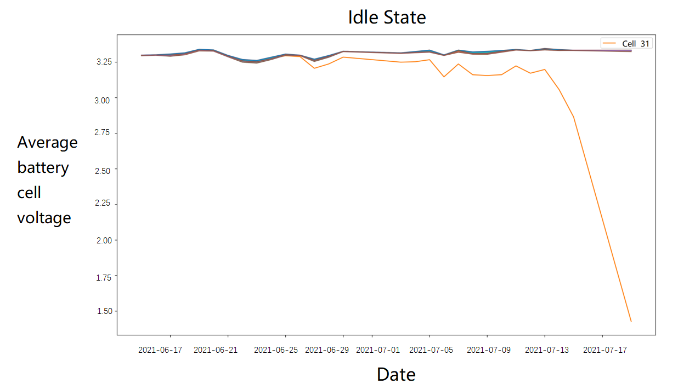

**Fig. 1** Average Battery Cell Voltage in Idle State.

From above investigation, it is clear that not all the data features are necessary. Battery cell voltage and total current are the primary features needed, which is also well explained by the physics behind self-discharging. A typical voltage distribution during a three-day battery usage is illustrated in Fig. 2, which is consistent with the normal operation range of LFP batteries.

**Fig. 2** Battery Cell Voltage Distribution

This paper aims to detect battery cells with abnormal self-discharge rates as early as possible. In the very early stage, the abnormality is too little to tell. However, based on long-term running data, even though the abnormality is small in its absolute value, it could exhibit a more observable trend of value changes over time like in Figure 1. Therefore, data becomes the most crucial input in this research, where a minimum of one month of data is used during the development of the initial version of the algorithm.

## Models and algorithms

Fig. 3 depicts the overall algorithm flow, which consists of five major steps. As described in Sec. 2.1, cell voltages, total current and their timestamps during vehicle operation are chosen as features for subsequent analysis. The data frequency is 5 seconds per frame, which is equivalent to 17280 frames of data per day; the cell voltage is accurate to 1mv. Total current is accurate to 10mA.

To ensure the accuracy of the study, this paper first clean the data with following steps:

* Fill with 0 if the data is missing;
* Delete the data row whose cell voltage is not in the range of [0,5];
* Delete the data row whose current value is not in the range of [-1000, 1000];

The current within [-5,5] ampere is classified as idle state; otherwise active state. Between two consecutive active states, there is one complete idle state. Two idle states are said to be continuous, if the difference between the finishing of the first idle state and the beginning of the second idle state is less than 10 seconds, or 2 frames of data.

As for detect digressive cells, this study will select the data segment with a single idle state that lasts more than 2 hours, delete the first 10 minutes’ of data from the beginning of the idle state, and divide the idle state data into 10 minutes chunks, and then calculate the average and the medium of all cell voltages in each chunk;

Clustering is then performed according to the average and the medium cell voltages at each chunk to identify outliers. When a cell is identified as an outlier more than 7 times, it is considered to be an abnormal outlier cell. Afterwards, one will calculate the slope of the average voltage of the abnormal cell at two adjacent chunks. When more than 6 slopes are negative and a linear fitting is performed on the average voltages of all chunks, and the slope of the fitting line is also negative, then the cell is confirmed to be a digressive cell.

The digressive cells identified in the previous step usually cause increasing pack voltage differences. If the pack voltage differences rise at positive rates and the digressive cells’ voltages decrease faster than a certain speed (0.25mV/s), then the digressive cells are confirmed to be abnormal self-discharging cells.

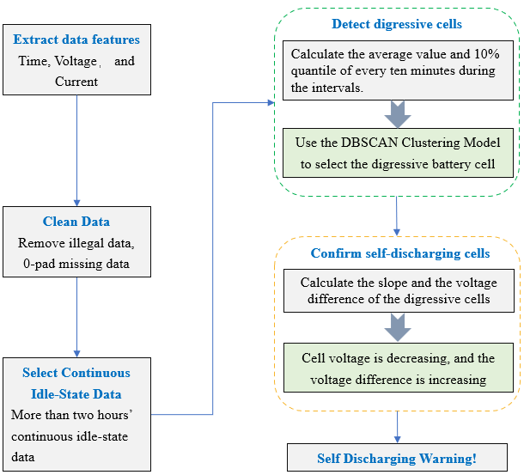

**Fig. 3** Self-Discharging Detection Algorithm

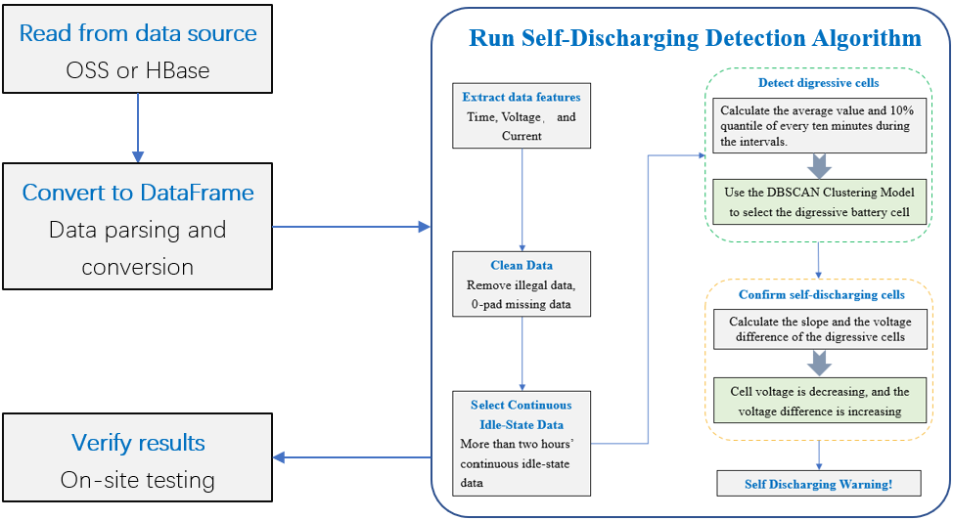

**Fig. 4** Evaluation Framework

# Results & Discussion

## Evaluation Framework

This research is a data driven analysis. Based on the abnormal cell behavior, an algorithm digests a vast amount of data, and detects self-discharging cells. However, to confirm the effectiveness of the algorithm, it must go back to the physical world and examine if the cells are indeed faulty. Therefore, the following evaluation framework shown in Figure 4 is designed. Electric vehicle data is collected, transferred, and finally stored in the data center. They are either in the form of files stored in OSS, a file-based storage service, or in the form of data saved in a database, such as HBase. To feed the algorithm, data must be read out first from them. This is done by an external data reader. Once data is read into the memory, they are extracted and reassembled into the DataFrame structure, for its high compactness, efficiency, and easiness to process by the downstream detection algorithm. The algorithm is developed with Python 3.8. So are the data reader and format converter in the previous two steps. Each self-discharging cell needs to be confirmed by testing it on-site. This is not only for the purpose of this research, but also a safety precaution measure because cell self-discharging usually gets worse over time and may cause fire. Once the on-site testing result returns, one can confirm the effectiveness of the algorithm, or if necessary, adjust certain thresholds due to false positive results.

## Evaluation Result

In this research, about one-month long data from 10 different vehicles was evaluated, and three anomalies with no false positive were found. The first case has been mentioned in Figure 1. In the following, more internal steps will be shown to better illustrate how the algorithm works.

In case 1, the data from the date of 6/10, 6/26 and 7/14 all in 2021 is analyzed. They show the cell voltage clustering result. On 6/10, all cells are in the same cluster (same black color in Figure 5 left panel). They are different by only 1mV, which is also the voltage sensing accuracy. 16 days later, on 6/26, one cell (#31) diverged from the others by 20mV (the black dot vs yellow dots in Figure 5 middle panel). At this point, the algorithm claims this cell is abnormal self-discharging. On 7/14, the diverging cell departed even farther away, by 400mV, from others (Figure 5 right panel). Then the local battery management system sent out the alert, and the subsequent on-site testing confirmed the result. Thus, the algorithm detected the anomaly about 20 days in advance.

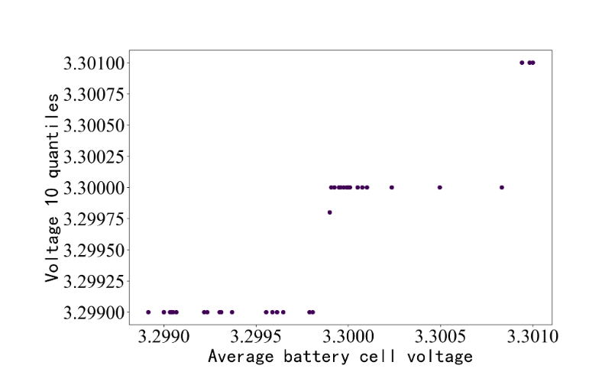 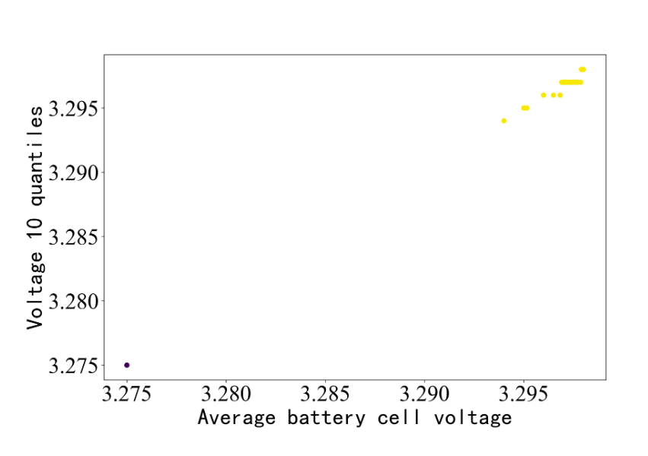 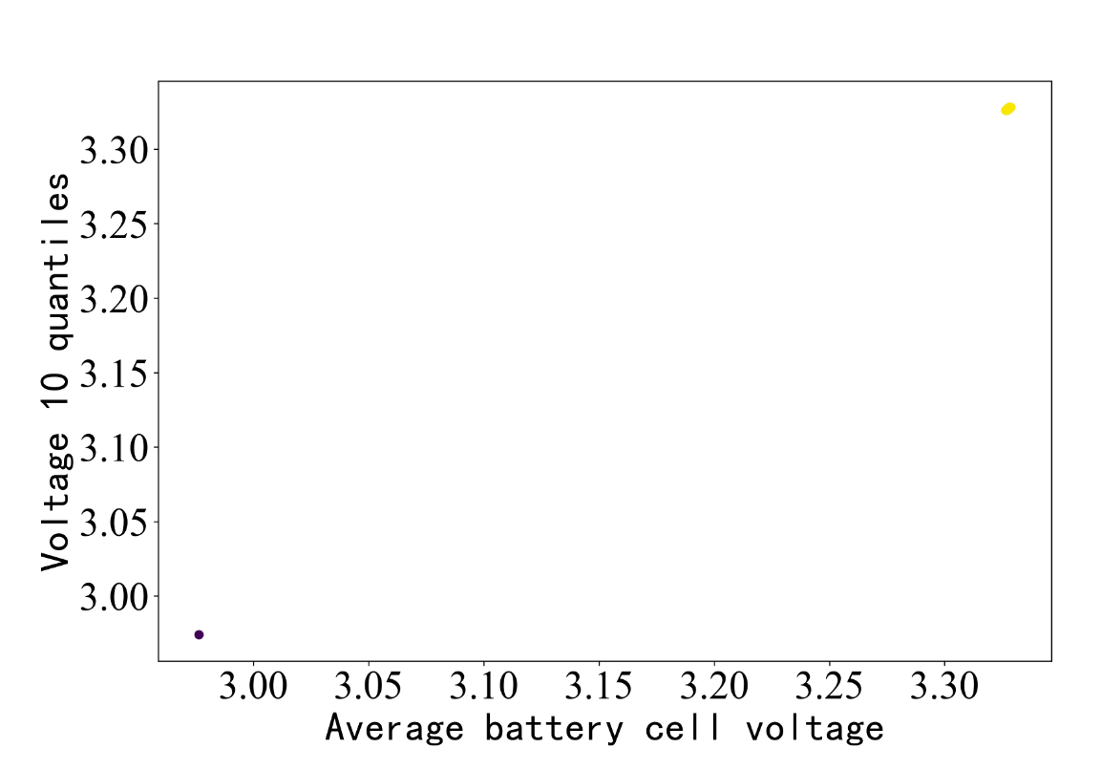

**Fig. 5** Cell voltage clustering diagram on 2021-06-10 (left panel), 2021-06-26 (middle panel) and 2021-07-14 (right panel).

Now, let’s look at the data in different presentations. Fig. 6 and Fig. 7 exhibit the voltage changes over time on 6/26 and 7/14 respectively. The left graph shows the abnormal cell (orange, #31) voltage diverging from others. The upper right graph shows the average voltages in 10-minute chunks. Cell #31 has its voltage moving lower and lower, and the decreasing rate exceeds the detection threshold. As a result, the pack voltage difference (lower right graph) is increasing higher and higher, also the fitting curve has a positive slope. Therefore, cell #31 is identified as an abnormal self-discharging cell.

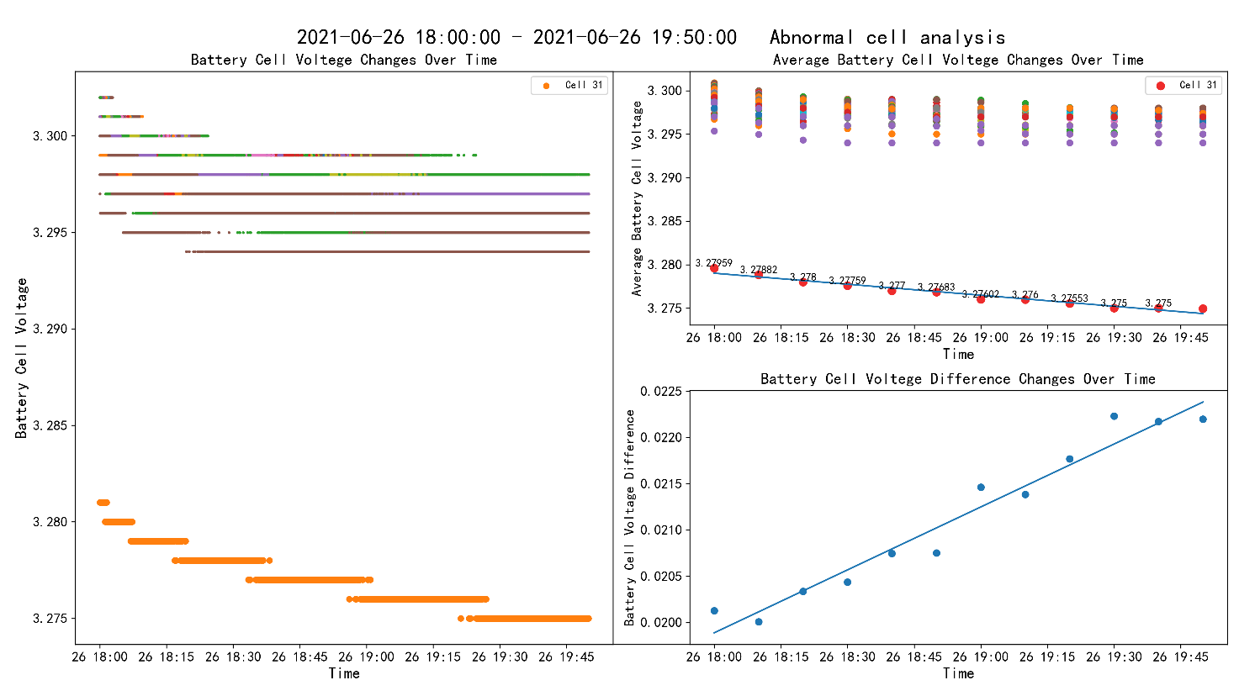

**Fig. 6** 2021-06-26 Abnormal self-discharging cell voltages

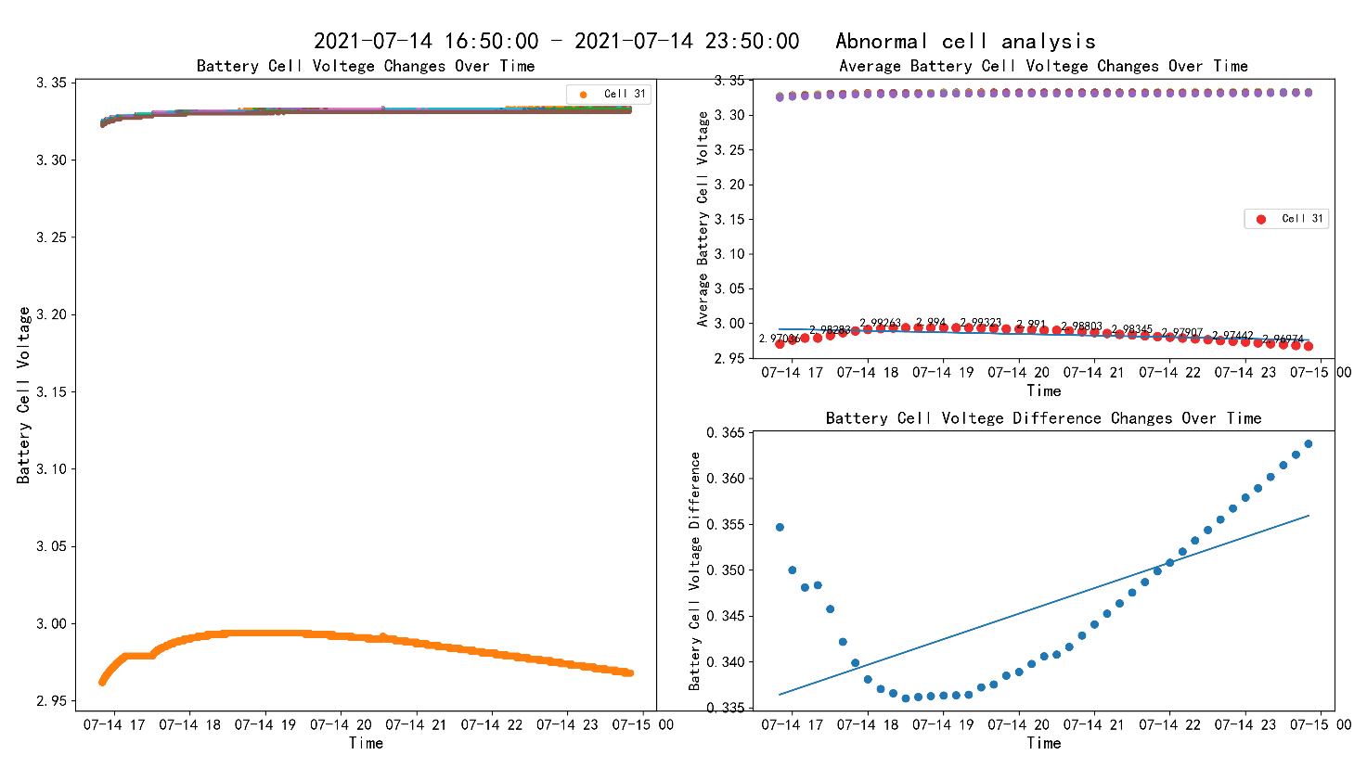

**Fig. 7** 2021-07-14 Abnormal self-discharging cell voltages

Case 2 and 3 are shown in Fig. 8 and Fig. 9. Same as the explanation for case 1, a particular cell is identified by its voltage decreasing and further claimed to be abnormal self-discharging. Both were indeed reported by the local battery management systems later. However, the detection algorithm predicts the fault 1.5 months and 5 months earlier respectively before they occurred.

|  |  |
| --- | --- |
|  |  |

**Fig. 8** Case 2: Abnormal self-discharging cell voltages

|  |  |
| --- | --- |
|  |  |

**Fig. 9** Case 3: Abnormal self-discharging cell voltages

## Application

Battery self-discharging is a rare but harmful phenomenon. No matter how well the battery manufacturing process is optimized, as the total amount of cells delivered quickly skyrockets to billions every year, rare events will surely happen. Therefore, the post monitoring and detecting effort become a must. The self-discharging method developed in this research starts with LFP batteries used in electric vehicles. However, it is not limited to one particular type of battery. Its theoretical principle and the algorithm apply to other types as well. Some popular application areas include NCM (Nickel Manganese Cobalt) batteries, and in the field of passenger cars, logistic vehicles, engineering machinery, energy storage systems, etc.

# Conclusion

In summary, this paper develops an early self-discharging detection algorithm for lithium-ion batteries. It takes advantages of the battery run-time data already collected by almost all electric vehicles. Even though the fundamental physics principle behind self-charging is straightforward, to be able to detect it far in advance, while the cell behavior is still similar enough to all others, isn’t an easy job. Long term data is used to examine the minute trend in the faulty battery’s behavior. To verify the effectiveness, month long data from 10 electric vehicles was run through the algorithm, and three self-discharging cases were detected. These results were further confirmed by on-site battery management systems, when the effect of self-charging became large enough to cause negative consequences, which occurred 20 days to 5 months after the algorithm successfully detects them. This time difference enables early preventative maintenance at the lowest cost, and most importantly, eliminates potential safety risks, whose value can never be over exaggerated.

Nevertheless, this study has some shortcomings. Firstly, the idle state requirement for some applications is difficult to satisfy. For instance, frequency regulation application would have the battery system running constantly. This could be dealt with by relaxing the idle state condition. Secondly, this research was done on LFP batteries. For NCM batteries, the algorithm detection threshold can be optimized. Because the OCV curve exhibits more monotonicity, it is suspected that the voltages of self-discharging cells drop even more quickly, therefore the algorithm can lower the threshold and detect the faulty cells even earlier. Finally, more active maintenance actions can be taken to better control the working condition and minimize the chance for self-discharging to occur; conversely after self-discharging happens, remedy with other regular battery management techniques such as balancing. Of course, the last improvement with active actions will be much more desirable but needs much deeper research in battery fundamentals.

Overall, this research work offers a guideline for developing early detection algorithms for lithium-ion batteries, which hopefully could benefit this rapid advancing industry segment.

# References

1. Yang Zengwu, Miao Meng, He Dilong. Progress of self-discharge behavior of lithium-ion battery[J]. Chinese Journal of Power Sources, 2016(6)：1309-1311.
2. Dai Haifeng, Wang Nan, Wei Xuezhe, Sun Zechang, Wang Jiayuan. A Research Review on the Cell Inconsistency of Li-ion Traction Batteries in Electric Vehicles[J]. Automotive Engineering, 2014, 36(2):181-188, 203.
3. Pei Pucheng, Chen Jiayao, Wu Ziyao, Self-discharge mechanism and measurement methods for lithium-ion batteries[J]. Tsinghua University (Science and Technology), 2019, 59(1):53-65.
4. Xu Tao, Gong Lu, Fang Lei, Wang Chenxu. Research progress in self-discharge of Li-ion battery[J]. Battery Bimonthly, 2016, 46(2):49-51.
5. Zheng Liuqun, Wan Lipeng, Chen Zhuhui, Zou Jianping. Effects of impurities on the self-discharge of Li-ion battery [J/OL]. Battery Bimonthly, https://kns.cnki.net/kcms/detail/ 43.1129.TM.20220530.1651.010.html, 2022.
6. He Penglin, Qiao Yue. The consistency and safety of multi-cell Li-ion batteries[J]. Battery Bimonthly, 2010, 40(3):161-163.
7. Liu Shuangquan. Research and Application of Self-discharge Detection for Li-ion Battery[D]. HeiLongjiang Harbin University of Science and Technology,2014.
8. Liao H, Huang B, Cui Y, et al. Research on a fast detection method of self-discharge of lithium battery[J]. Journal of Energy Storage, 2022, 55: 105431.
9. Hou YanLing. Rapid Detection and Experimental Study of Self-Discharge Characteristics of Lithium Ion Batteries[D]. Guangdong：Guangdong University of Technology, 2019.
10. EVE Power. A Screening method for self-discharge of lithium-ion batteries: 202110884188.0[P]. 2021.10.08.